Name ________________________________________________

This skills check covers pre-requisite material needed for the first unit of the course, limits. You should practice these ideas to ensure that you can quickly and correct answer such questions. Being able to do so will make learning the calculus material of the first unit much easier. It’s never fun to be held up by Algebra when trying to learn Calculus! This is just a sample for practice. You may receive help on these questions and work with other students.

- Graphing Piecewise Functions
- Graph the following piecewise function:
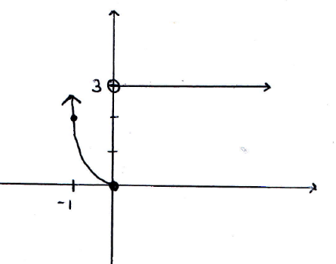

- Graph the following piecewise function:
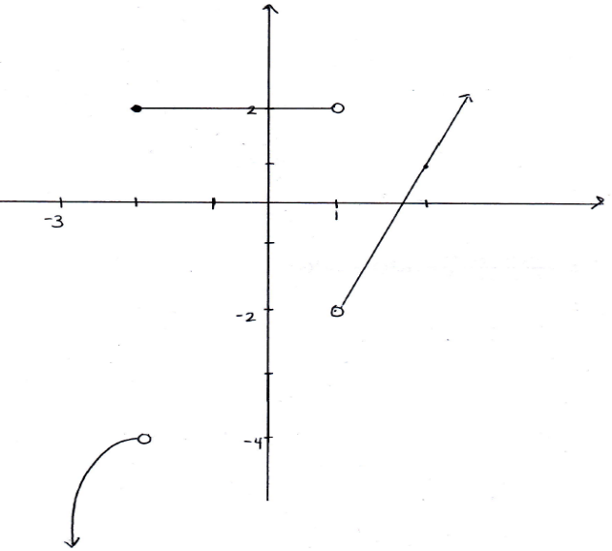

- Graph the following piecewise function:

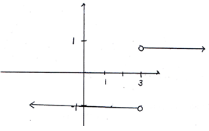

- Simplifying Rational Expressions
- Complete the following subtraction and fully simplify the result:

- Complete the following addition and fully simplify the result:

- Complete the following subtraction and fully simplify the result:

- Solving Absolute Value Inequalities
- Determine the interval communicated by the inequality:
In order for the given statement to be true we know that:

- Determine the interval communicated by the inequality:

In order for the given statement to be true we know that:

- Determine the interval communicated by the inequality:

In order for the given statement to be true we know that:
This implies that:

- Rationalizing numerators or denominators
- Rationalize the denominator of the fraction:

- Rationalize the denominator of the fraction:

- Rationalize the numerator of the fraction:

- Evaluating and simplifying functions
- Setup and simplify the expression using the function:

- Setup and simplify the expression using the function:

- Setup and simplify the expression using the function:

